**Angeles  City Science High School**

**Consumer Chemistry 9**

**Name:** Paul Gerald D. Pare **Section:** 9 - Adenine

Activity 1: Sweet Terms

Objective: Recall the terms in food additive and sweetening agents

Direction: Decode the abbreviations below. Write your answer on the space provided.

1. FDA - Food and drug administration
2. GMP - Good manufacturing practice
3. HFCS - High-fructose corn syrup
4. MSG - Monosodium glutamate
5. BHA - Butylated hydroxy anisole
6. BHT - Butylated hydroxytoluene

Guide Questions

1. What are the food additives approved by FDA? Give three (3) examples.

Citric Acid, High-fructose, Caramel Color.

1. What are the Sweetening agents approved by FDA? Give three (3) examples.

Aspartame, Neotame and Saccharin.

1. How does FDA approve a food additive or sweetening agents?

The food additives being used should present no risk to the health of the consumer at the levels of use.

Activity 2: Midnight Present!

Objective: Examine the food for food additives and sweetening agent

Direction: The picture below is your MIDNIGHT SNACK. Detect the food additives and sweetening agent present on your midnight snack. Write on the space provided

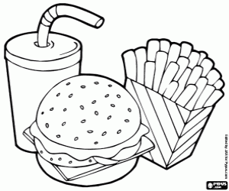

**Food item #3: Hamburger Food additives**: Salt, monosodium glutamate, Soy bean oil, niacin, Mono- and Diglycerides.

Food item #2: Potato fries Food additives: Salt, monosodium glutamate, Soy bean oil, BHA, BHT.

Food item #1: No sugar Soft Drinks Food additives: Acesulfame K, Aspartame, Cyclamates, Saccharin, Thaumatin.

Guide Questions

1. What will happen if you take out the one (1) food additive on hamburger?

The food will not be the same. It may taste unflavored or has molds.

1. Why do food manufacturers include additives on their product?

Food additives are added to the products to last it expiration date and to make it more appealing to the consumer serves.

1. Does NO SUGAR product has sugar?

Yes, artificial sweetener.

Activity 3: Sweetness INTENSE

Objective: Summarize the different levels of artificial sweetener using a table Direction:

* 1. Carefully read the Background Information – Most Popular Artificial Sweeteners
  2. Complete the Table 2 below

Table 2: Sweetness Level Of Each Artificial Sweetener Compared to Table Sugar.

|  |  |  |  |
| --- | --- | --- | --- |
| Artificial Sweetener | Multiplier of Sweetness Intensity  Table Sugar (Sucrose) | Amount of  Calorie/s | Product/s |
| Aspartame | 200x | 0 | Soft drinks, gum, yogurt, and cough drops. |
| Neotame | 7000x to 13000x | 0 | Dairy products, frozen desserts, pudding, and fruit juice |
| Ace-K | 200x | 0 | Frozen desserts, candies, beverages, and baked goods. |
| Saccharin | 300x to 500x | 4 | Toothpaste to candy to canned fruits and vegetables |
| Sucralose | 600x | 0 | Sugar substitute in baking recipes. |
| Sugar alcohols | 0.25x to 1x | 0-3 | Sugar-free gum and mouthwash |
| Stevia | 200x to 400x | 0 | Diet drinks, yogurts. |

Guide Questions

1. Which artificial sweetener has the highest Multiplier of Sweetness Intensity?

Neotame

1. Which artificial sweetener has the lowest Multiplier of Sweetness Intensity?

Sugar alcohols

1. Which artificial sweetener has the highest amount of calories?

Saccharin

1. Which artificial sweetener has the lowest amount of calorie?

Aspartame, Neotame, Ace-K, Sucralose, Stevia containing no calories

1. Is sweetness intensity related to amount of calories? How?

Yes, the higher Multiplier of Sweetness Intensity Table Sugar (Sucrose), the higher amount of calories.

Activity 4: Stack it Up

Objective: Illustrate the different levels of artificial sweetener by constructing a Bar graph.

Direction:

* 1. Using the Table 2 (above), show the comparison of sweetness level of each artificial sweetener to sugar by constructing a Bar graph.
  2. Use the minimum sweetness intensity of Artificial sugar
  3. Color and Label the x and y of your bar graph.

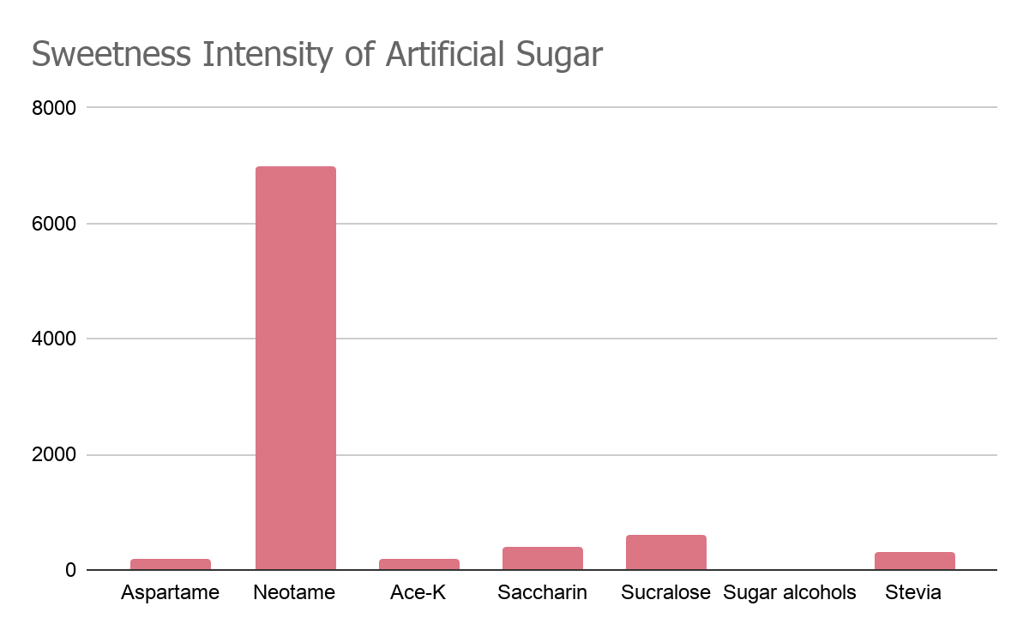

Guide Questions:

1. What is the value place in the X-axis?

Artificial sugar

1. What is the value place in the Y-axis?

Multiplier of Sweetness intensity Table Sugar(sucrose)

1. Is sweetness intensity related to the height of the bar? How?

Yes, the higher Multiplier of Sweetness intensity Table Sugar (Sucrose), the higher the height of the bar.